Assignment-01

While traveling, you meet an IT professional who writes plays in their spare time. They are working on a play that really resonates with you. Part of the concept of the play is that it is open source. After a spirited discussion on your flight, they tell you about the repository where the play is kept and encourage you to get involved. To contribute, you will first need to install Git and configure it with your name and email address. Once that is done, you need to pull down the repository into /home/<user-name>/play/ on the provided workstation host. Create a new branch named after your first name to begin your piece of the story. Create a new text file with your story and add it to the branch. Also, add your name to the contributers.txt file within your branch. Be sure to track your work with git and commit your changes to your local repository and use the commit message "airplane story" so your travel buddy will remember who you are!

Summary tasks list:

Install and configure git on the provided workstation.

Clone the repository from https://github.com/satyensingh/content-git-quickstart.git to /home/<user-name>/play and create a new branch for your story.

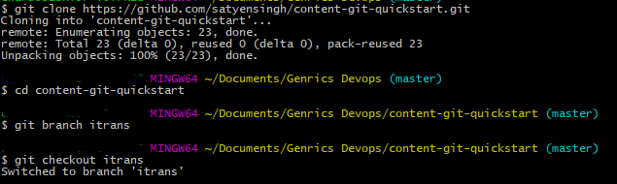

Add a new story file to your local repository in your new branch.





Add an entry to the file contributers.txt in your new branch.



Commit your changes using the message "airplane story".

**git commit -m “airplane story”**

**Assignment 03**

The development team in your organization is working on a new Web-based API. They have deployed a central server that they intend to use as a local Git repository for source control. They have managed to configure some of the global settings for the service account they want to use as the Git user, but are having difficulties in getting started with an empty repository.

As a result, they have provided you with the credentials for the service user and credentials to access their server. You have been asked to initialize a new Git repository in the /home/<user-name> directory called 'web-api'.

Once you have this new repository created, create a file called 'README.md' (be careful to mind the case of the file in order to follow your corporate standards for README files) that contains "Web-API v1" text. You will then need to add that file to the repository and commit the changes to the repository. Once you confirm that the default branch is up-to-date with no changes to commit, you may turn it back over to the team for use.

